**Name:** Soham Bhoir

**Roll No.:** 16010420117  
**Batch:** A4

**Experiment 3:** Creating Window Virtual Machine Instance using AWS (IaaS)

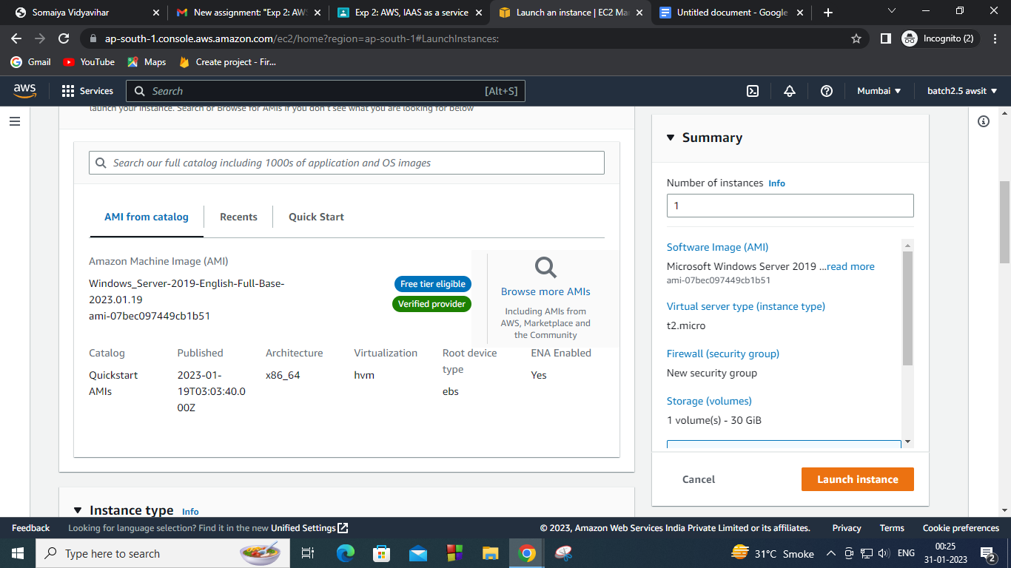

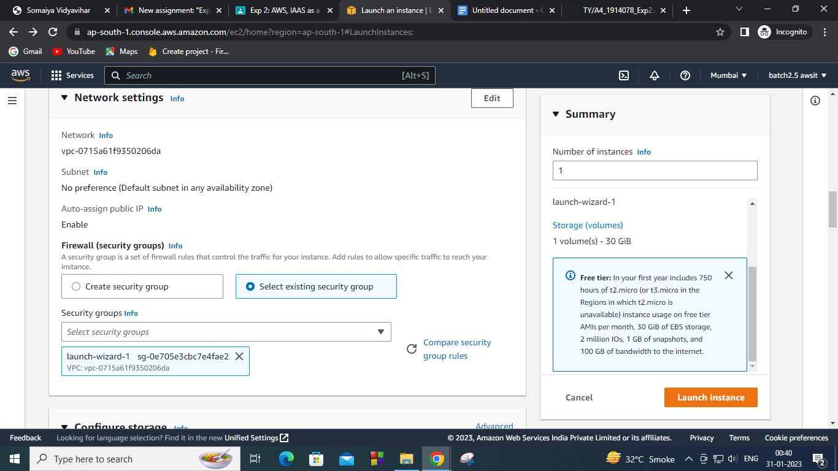

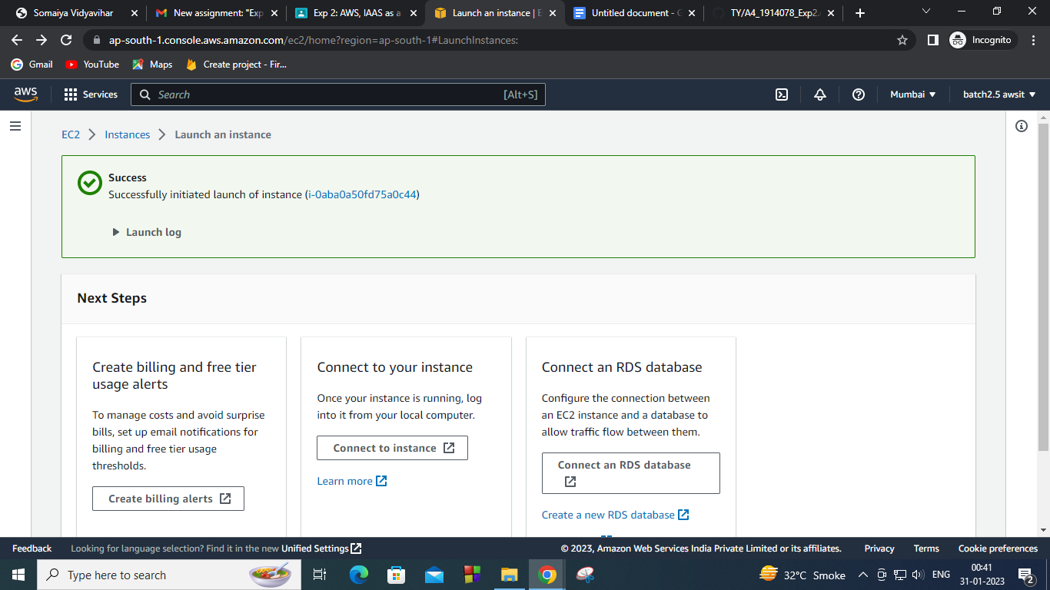

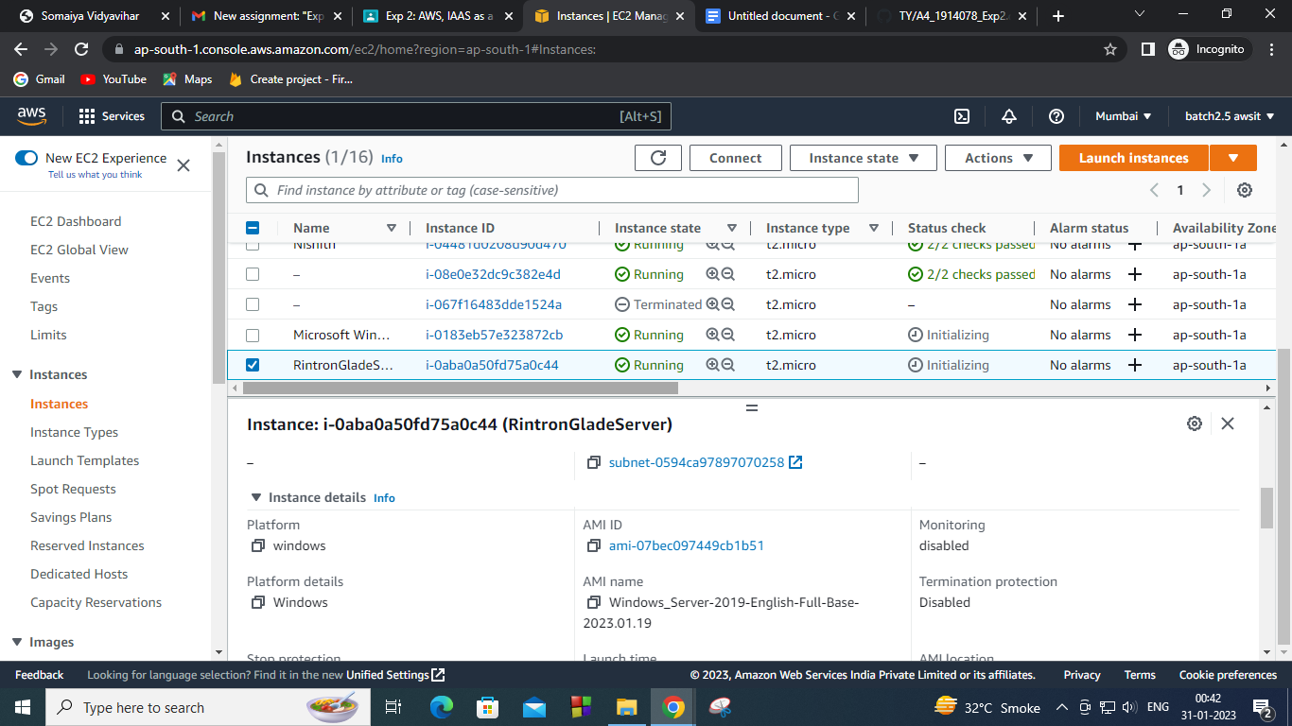

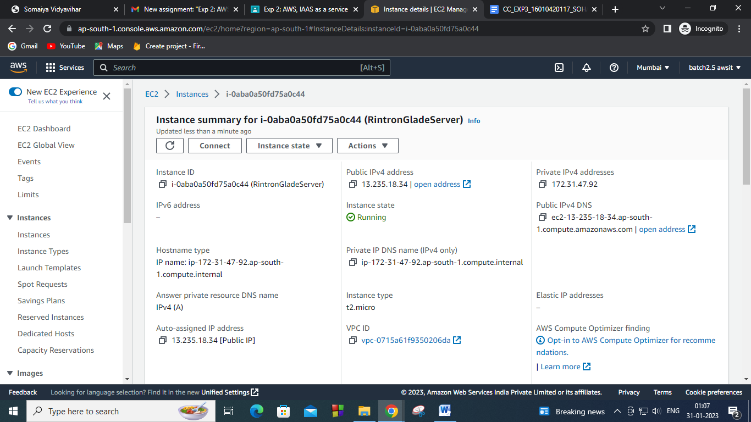

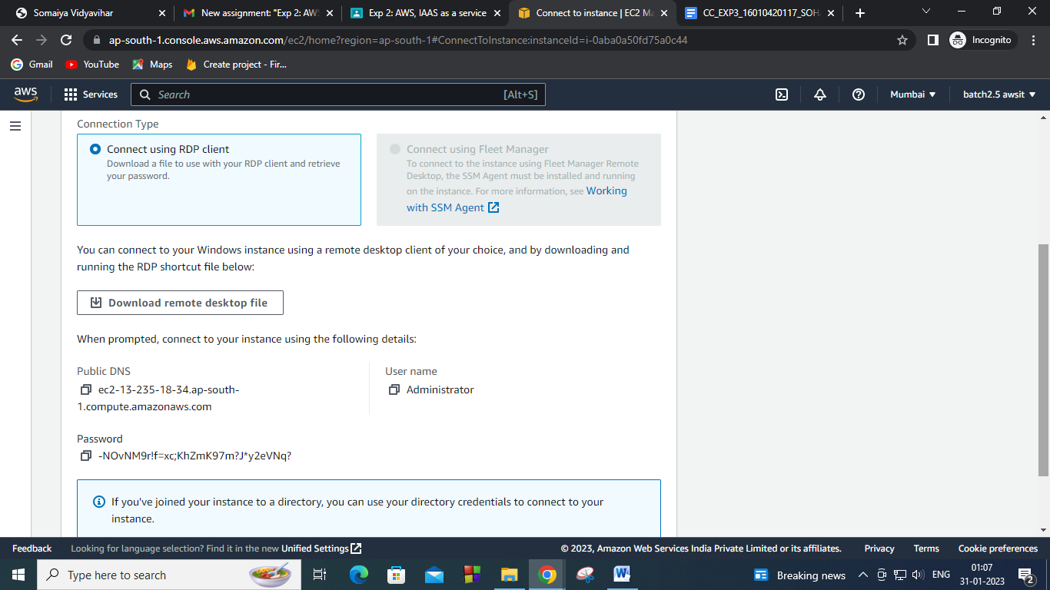

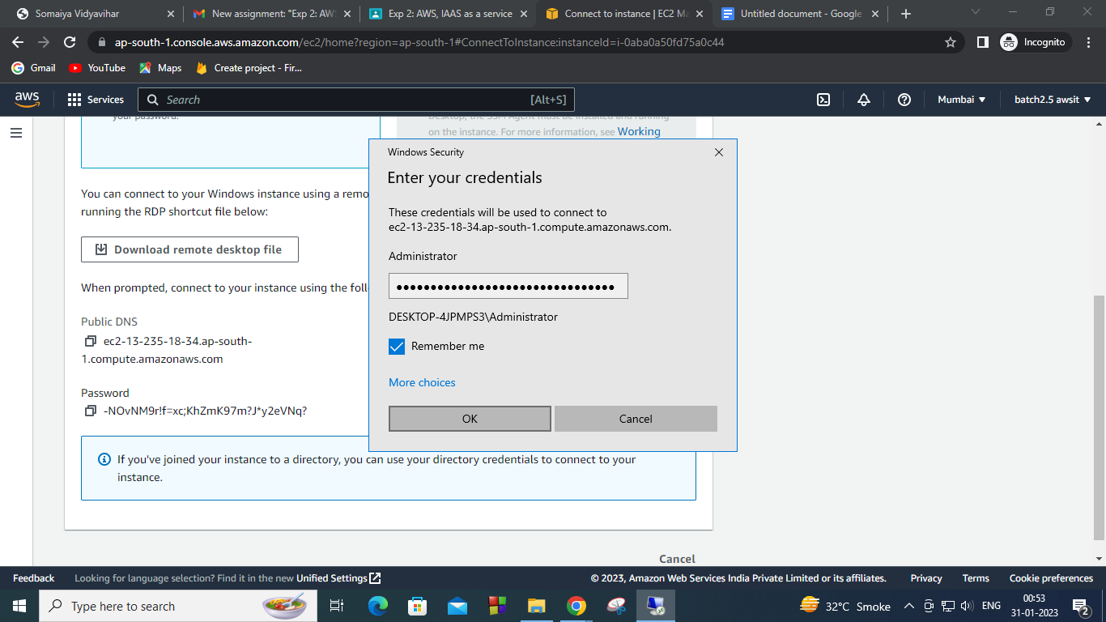



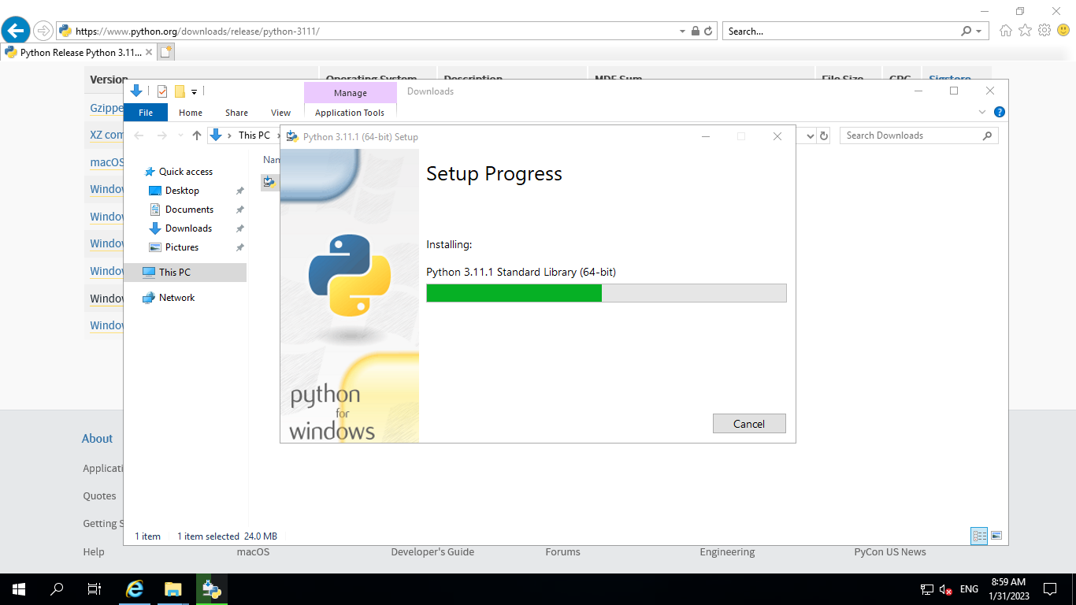

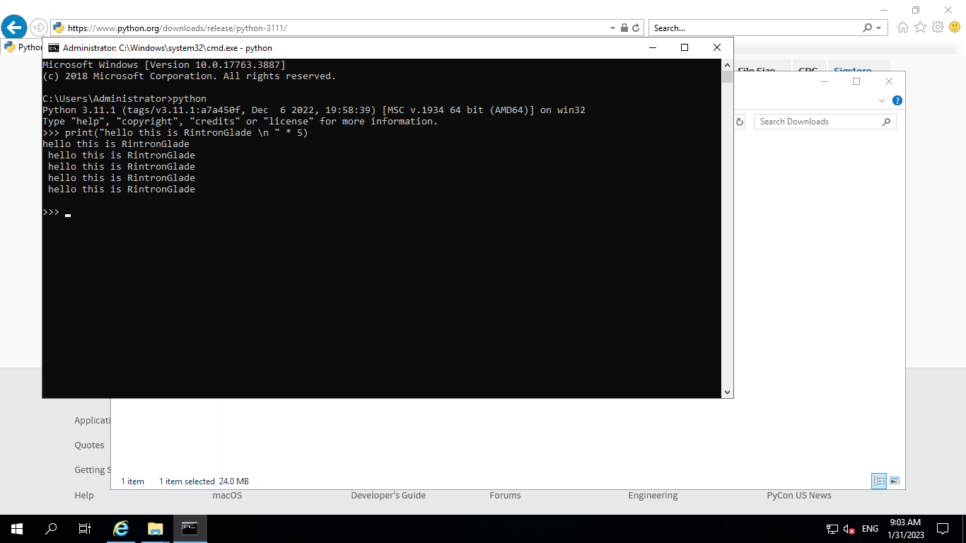

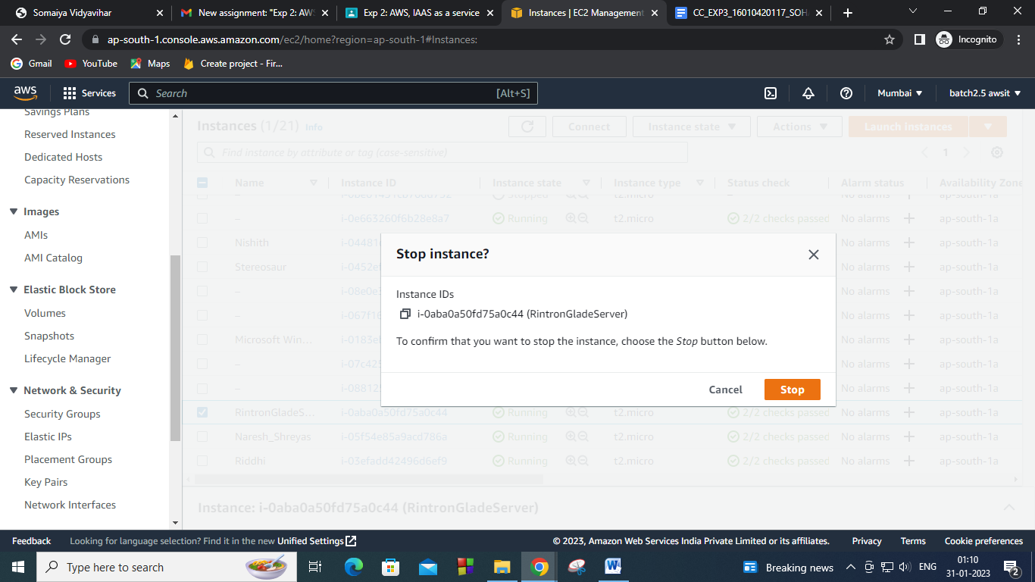

**Questions**

1. Explain two AWS IaaS, PaaS and SaaS services for each?

Ans:

a. IaaS

i. EC2: Amazon Elastic Compute Cloud (Amazon EC2) provides scalable computing capacity in the Amazon Web Services (AWS) Cloud. Using Amazon EC2 eliminates your need to invest in hardware up front, so you can develop and deploy applications faster.

ii. S3: Amazon Simple Storage Service (Amazon S3) is an object storage service that offers industry-leading scalability, data availability, security, and performance. Customers of all sizes and industries can use Amazon S3 to store and protect any amount of data for a range of use cases, such as data lakes, websites, mobile applications, backup and restore, archive, enterprise applications, IoT devices, and big data analytics.

b. PaaS:

i. Elastic Beanstalk: AWS Elastic Beanstalk is an easy-to-use service for deploying and scaling web applications and services developed with Java, .NET, PHP, Node.js, Python, Ruby, Go, or Docker on familiar servers such as Apache, Nginx, Passenger, and IIS. Elastic Beanstalk is a complete application management solution, and manages all infrastructure and platform tasks on your behalf.

c. Saas:

i. Dropbox.

ii. Salesforce.

iii. Cisco WebEx.

iv. SAP Concur.

v. GoToMeeting.

**Outcomes:**

**CO2: Study the Evolution of Cloud Computing and its models**

**Conclusion: (Conclusion to be based on the objectives and outcomes achieved):**

Launched a Windows Instance on AWS EC2 and executed a python script.